Game Design Document

Fill up the following document

1. Write the title of your project.

The Shadows of The Enchanted Jungle.

1. What is the goal of the game?

The goal of the game is to compete against the fellow players and

reach the treasure box first.

1. Write a brief story of your game.

An evil supernatural creature (cursed witch) rules the town, the four players

are her slaves. The treasure box has a jewel which has the capability to lift

the witch’s curse. She has promised to give freedom to the person (one of

the players) if they get her the box.

1. Which are the playing characters of this game?

* Playing characters are the ones who respond to the user based on the input from the user.
* Cars, monkeys, dinos, wizards, etc., are the playing characters in the game.

|  |  |  |
| --- | --- | --- |
| Number | Character Name | What can this character do? |
| 1 | Player one (own name) | Has complete control, competes against the fellow players, collects coins, avoids obstacles and monsters. |
| 2 | Player two (own name) | Has complete control, competes against the fellow players, collects coins, avoids obstacles and monsters. |
| 3 | Player three (own name) | Has complete control, competes against the fellow players, collects coins, avoids obstacles and monsters. |
| 4 | Player four (own name) | Has complete control, competes against the fellow players, collects coins, avoids obstacles and monsters. |
| 5 | Na | Na |
| 6 | Na | Na |
| 7 | Na | Na |
| 8 | Na | Na |

1. Which are the Non-Playing Characters of this game?

* Non-Playing characters are the ones that don't have an action or behaviour when the user interacts with the game.
* Hurdles, stones, bananas, coins, etc., are non-playing characters in the game.

|  |  |  |
| --- | --- | --- |
| Number | Character Name | What can this character do? |
| 1 | Monster one | Gets in the way of the player and decreases their speed/makes them lose a life. |
| 2 | Monster two | Gets in the way of the player and decreases their speed/makes them lose a life. |
| 3 | Gems | Increases the speed of players and makes players richer. |
| 4 | Obstacle one (rock) | Decreases the speed of the player. |
| 5 | Obstacle two (poisonous mushroom) | Decreases the speed of the player. |
| 6 | Obstacle three (ant hill) | Decreases the speed of the player. |
| 7 | Bats | Get in the way of the player and decrease their speed. |
| 8 | The cursed witch | Nothing to intefere in the working of the game, rules the players. |

1. Draw your imagination of this game. What does this game look like?

* Draw the game either on your computer or on paper.
* Add images of the game scenes to show each of the playing and non-playing characters at least once.

i. scene one – showing the cursed witch and explaining the back story.

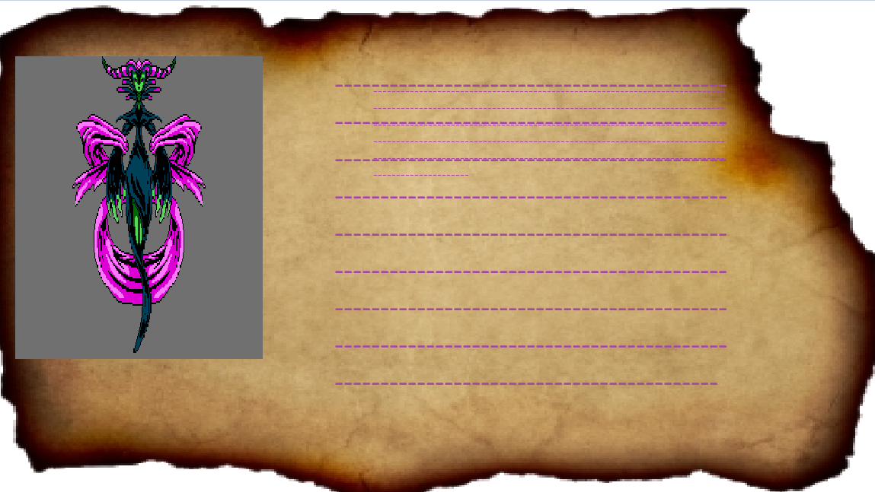

ii. scene two – showing the different obstacles/monsters the players may come across and the gems to collect. (background might differ.)

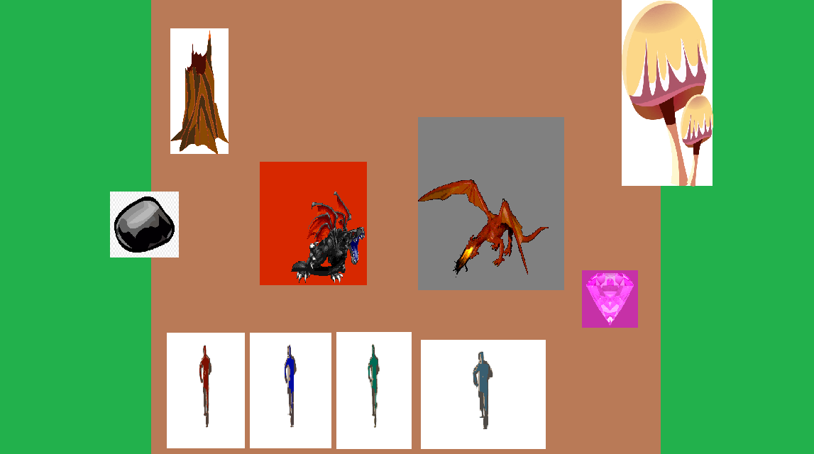

iii. scene three – showing the last scene which will only pop up on the winning players screen.

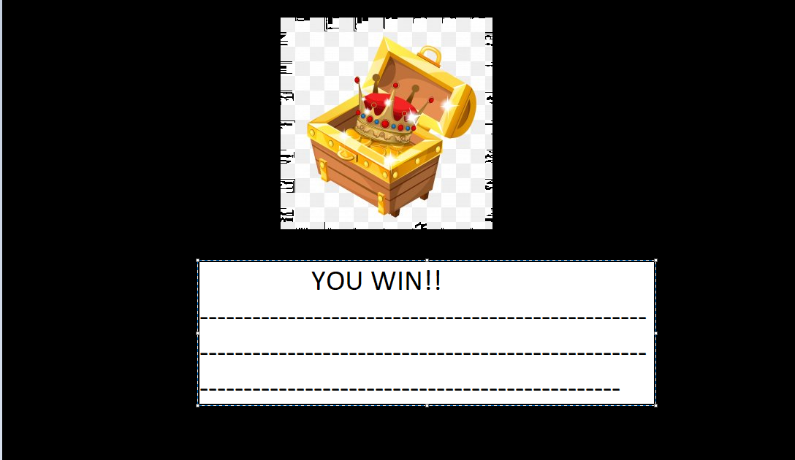

1. How do you plan to make your game engaging?

Responses/feedback like the score display, sounds, lives display; the different variety of hurdles/obstacles; the animations; competing against real people/friends; creative storyline with a definite goal will make my

game engaging to play.